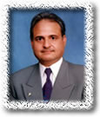 | Dr. Muhammad Hafeez
Chairman & Professor
Punjab University
 | M.A.(Pb), M.A.(Can), Ph.D. (Aus) CPL (IR)
 | Specialization: Sociology
Phone Number: 92-42-99231231
E-mail Address: chairman.soc@pu.edu.pk,
 | hafeez.soc@pu.edu.pk

